Mrs. Glaser’s Third Grade News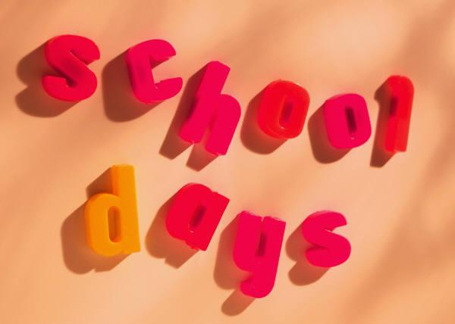

September 6 , 2019

Dear Parents and Students,

We made it through the first week of Third Grade! Wow!! It was fantastic!

This week we have gone over the room routines and procedures your child will use on a daily basis. It is so important that your child do the right things at the right time. The major procedure that I really need you to stress with your child is to listen to the directions and do what I say right away. I know this has taken quite a bit of time and your child will get better by next week, and if it doesn’t improve they will have lots of homework as their work time will be too short to get things completed. I will contact you if the problem seems to continue.

Your child will have reading every night for 20-30 minutes as that is a school requirement for third grade. A reading log is not given this year so just sign their assignment notebook.

Your child also needs to practice their addition and subtraction facts nightly if they did not score better than 90% on their timed tests this week. We will be working on multiplication this year so they are to have mastered their addition and subtraction facts by third grade. We will be using the math program Reflex Math to reinforce these facts.

Please remember to send a healthy snack for snack time each day as they need to provide their own on a daily basis.

Also remember to sign your child’s assignment book nightly and make sure they have completed work that is written down in it. It will usually be reading, math sheet and flash cards, and practicing their spelling words. If they used their time at school wisely they will have most done before they go home.

Remember that we live in Two Rivers and the weather changes quickly, so please send a coat/sweatshirt every day.

If anytime this year you have any questions or concerns, please feel free to contact me by calling or e-mail me at [mary.glaser@trschools.k12.wi.us](mailto:mary.glaser@trschools.k12.wi.us), 793-1118 ext. 3014 and I will get back to you as soon as I can.



I know we are going to have a wonderful year!